LAB221 Assignment | Type: | Short Assignment
 | Code: | J2.S.P0009
 | LOC: | 29
 | Slot(s): | 1

Title
A Simple notepad
Background Context
We often use a very simple text editor that is available in every window family. With java swing, you can also easily make a simple notepad with basic functions of edit menu: cut, copy, paste, select all.
Program Specifications
Create an application using swing jtextarea and jmenu to create a simple notepad (1)
1. Main.java
Make a frame look like description below.

Function details:
- Display the GUI like figure (1)
- When users a menu item from Edit menu, the system will do corresponding task.

Expectation of User interface:

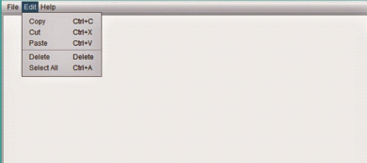 (1)
Guidelines
You can use JTextArea for the editor.

